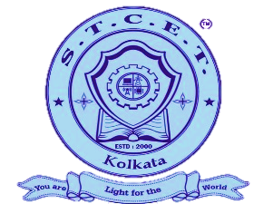
St. Thomas’ College of Engineering & Technology
Kidderpore, Kolkata, West Bengal


Electronic Trends

Department of
Electronics & Communication Engineering

V O L U M E X : 2 0 2 5 - 2 6

For Further Information Contact: prasun.chowdhury@stcet.ac.in
For Feedback Contact: priyanka.saha@stcet.ac.in

